WEEK-1 SKILL

WSL INSTALLATION
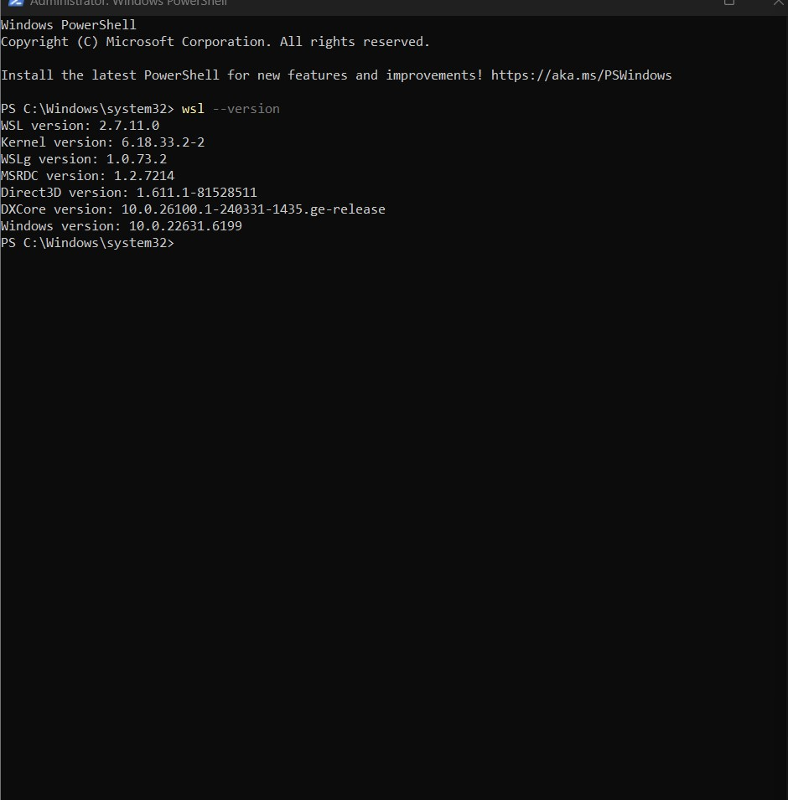
Report : I installed WSL using PowerShell. After that, I checked the installation using the wsl --version command, and it displayed the WSL version, kernel version, and Ubuntu details.

SIMPLE COMMANDS:
1.Pwd:
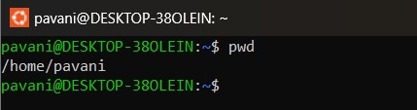
Report : When I executed the pwd command, it displayed my current working directory as /home/pavani
2.Clear:
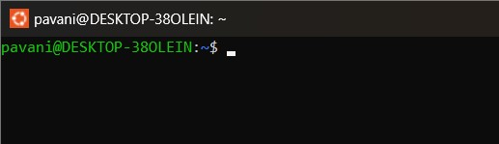
Report:After running the clear command, the terminal screen became empty and the cursor moved to the top of the screen.
3.history
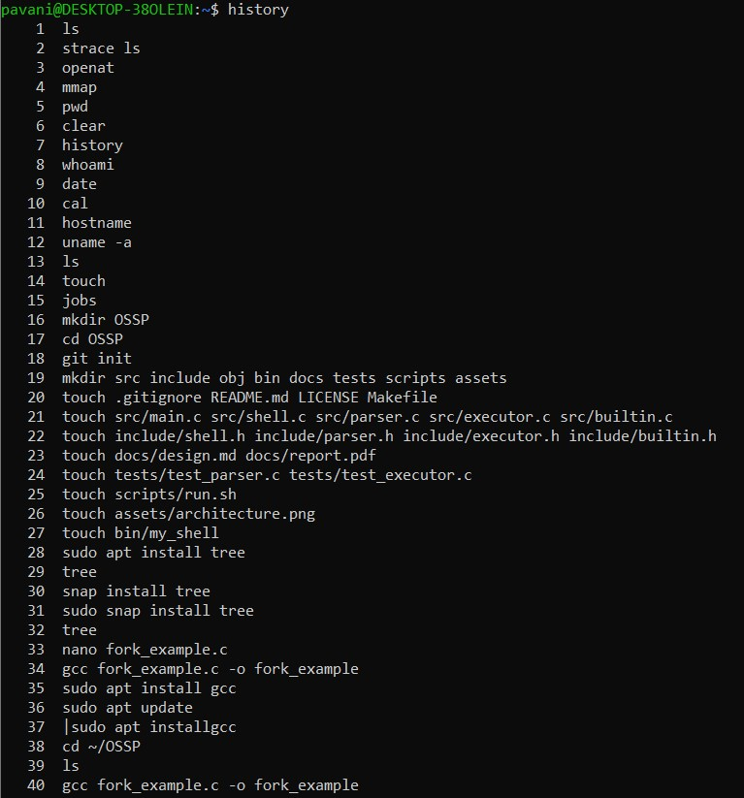
Report: The history command displayed all the commands I had executed previously in the terminal.
4.Whoami:
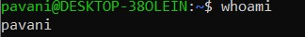
Report: The whoami command displayed my current username as pavani.
5.date:
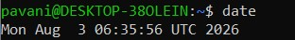
Report: The date command showed the current system date and time
6. cal:
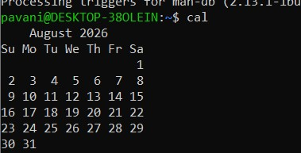
Report: The cal command displayed the calendar for August 2026.
7.hostname:
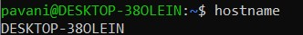
Report: Displaying the network host identifier for the systeThe hostname command displayed my system name as DESKTOP-38OLEIN.
8.uname -a:
Report: The uname -a command displayed information about the Linux kernel and my operating system.

TOPIC 2:
9.Ls:
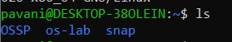
Report: The ls command displayed the folders available in my current directory, such as OSSP, os-lab, and snap.

10.ls -l:
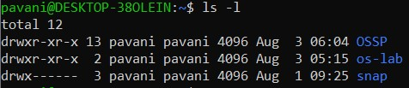
Report: The ls -l command displayed detailed information about the files and folders, including permissions, owner name, size, and date.

11. ls -a:
Report: The ls -a command displayed all files, including hidden files like .bashrc, .profile, and .config.

12.cd:
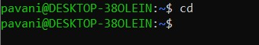
Report: goes back to the user user’s home folder

13.cd ..:
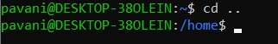
Report: The cd .. command moved me from my current directory to the parent directory.
14.mkdir:
Report: I created a new directory named projects, and it was successfully added to the current location.
15.rmdir:
Report : The rmdir command removed the empty projects directory successfully.
16.find:

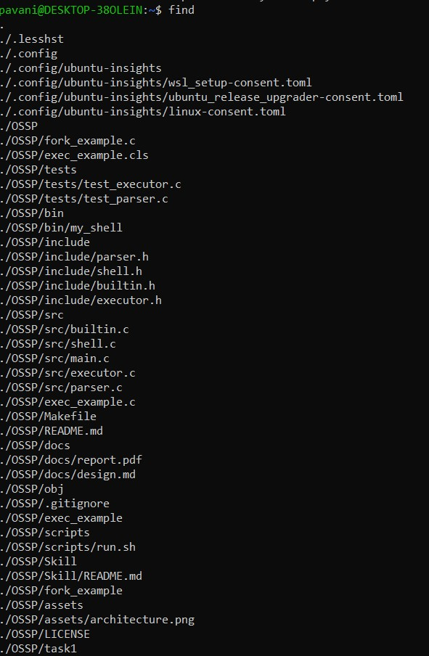

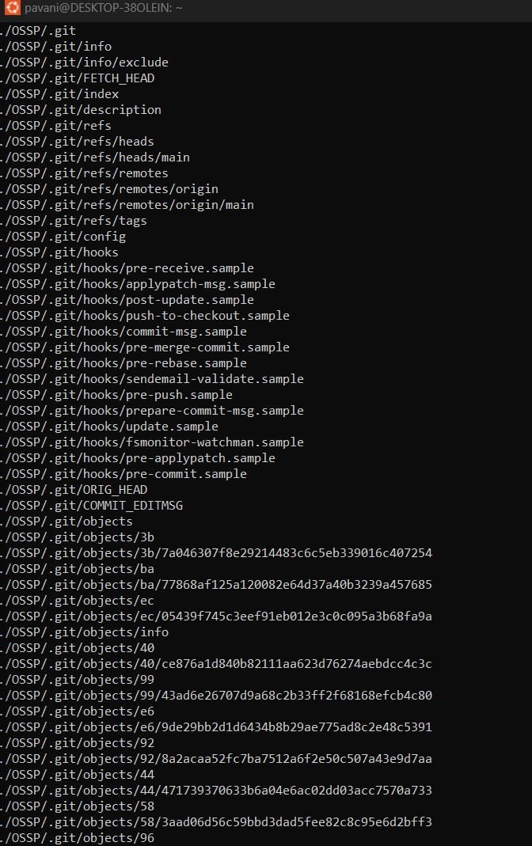
Report: The find command displayed all the files and folders inside my current directory, including files inside OSSP, .config, and .git folders.
. TOPIC -3
17.Touch:
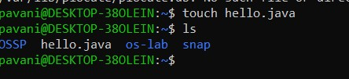
Report : The touch command created a new empty file named hello.java.
18.Cat:
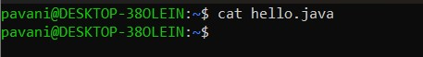
Report: When I executed the cat command on hello.java, no output was displayed because the file was empty.

19.Cp:
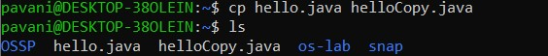
Report: The cp command created a copy of hello.java with the name helloCopy.java.
20.Mv:
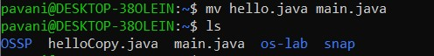
Report: The mv command renamed hello.java to main.java successfully.
21.rm:
Report: The rm -r command removed the snap directory and its contents.
22. head:
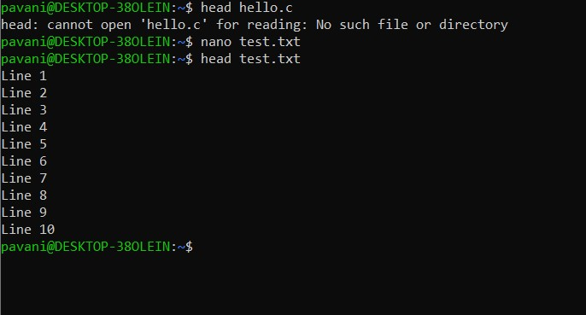
Report: The head command displayed the first 10 lines of test.txt, from Line 1 to Line 10.
23.tail:
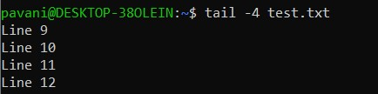
Report: The tail -4 command displayed the last four lines of test.txt, from Line 9 to Line 12.
24.more:
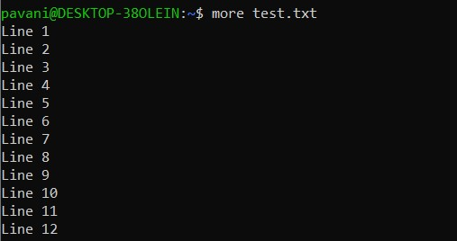
Report: The more command displayed the contents of test.txt one screen at a time.
25.less:
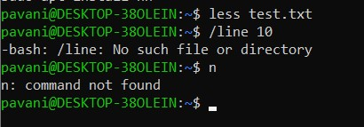
Report: The less command opened test.txt. When I tried searching incorrectly, it showed a message because no previous search pattern was available.
26.wc:
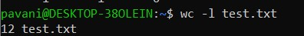
Report: The wc -l command counted the number of lines in test.txt and displayed 12 lines.

27.diff:
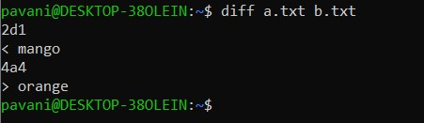
Report: I compared the files a.txt and b.txt. The terminal showed the lines that were different, like mango and orange, so I understood which content had changed
28.sort:
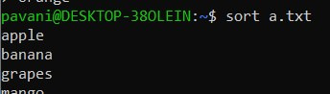
Report: After running the sort command, the words in a.txt were arranged in alphabetical order. The output started with apple, followed by banana, grapes, mango, and orange .
29..uniq:
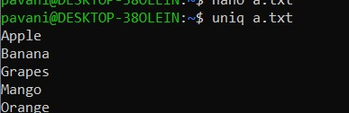
Report: The uniq command displayed only the unique lines in the file. Since there were no repeated consecutive lines, all the words were shown only

30. grep:
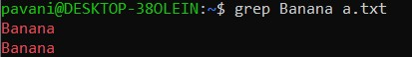
Report: I searched for the word Banana in a.txt. The terminal displayed the matching lines where the word was found.
TOPIC 4 : FILE EDITING 33. nano:
Report: The screen switched to the nano interface showing shortcut controls at the bottom, where I was able to edit and save my C code.
- vi:
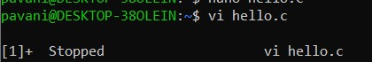
Report: Running vi hello.c opened the editor, and pressing Ctrl+Z paused it and put it into the background as [1]+ Stopped
TOPIC 5: C Program Compilation and Execution
- gcc :
Report: The command compiled cleanly without any errors and generated an executable binary file named hello in my current directory 36. ./program:
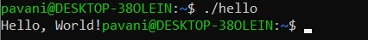
Report: The program ran and printed Hello, World!
- which:
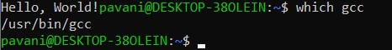
Report: The shell searched the system environment paths and printed /usr/bin/gcc to show where the compiler binary is saved
- where is:
Report : The whereis command showed the locations of the gcc compiler, its libraries, and its manual pages on the system.
39.man:
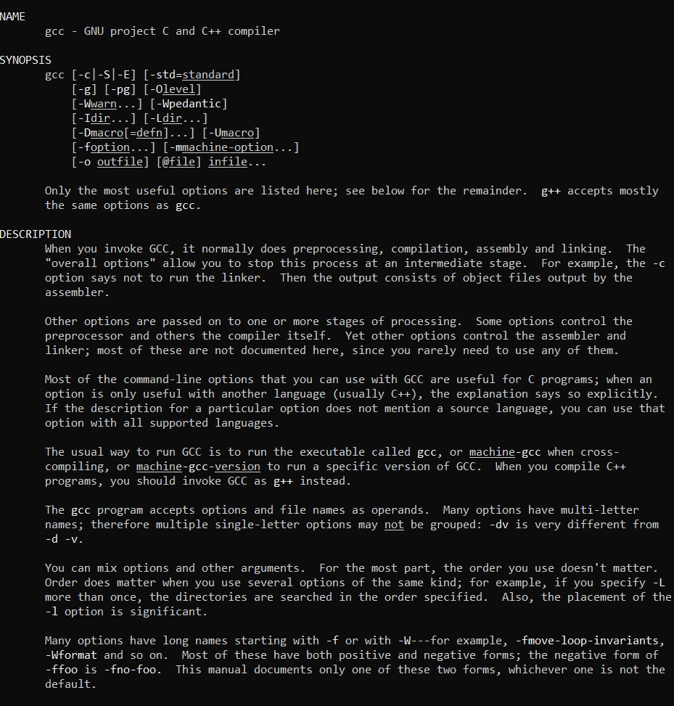
Report : Opened a scrollable documentation page listing all syntax rules and flags for gcc, which
I exited by pressing q TOPIC 6: Process Management
40.ps:
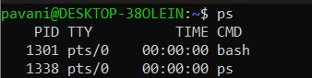
Report : The ps command displayed the processes running in my current terminal, such as bash and the ps command itself.

41.ps -ef:
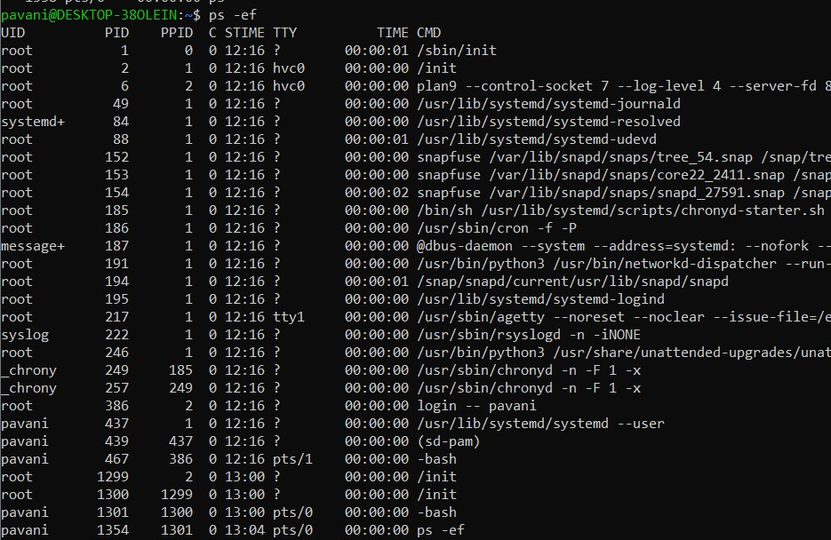
Report: The ps -ef command displayed all the running processes in the system along with their process IDs and user details.

42.top:
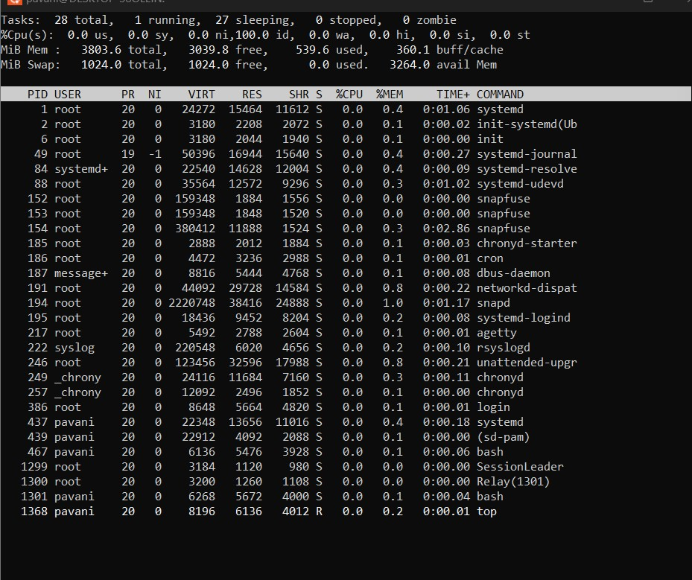
Report :The top command showed the live status of the system. I could see the CPU usage, memory usage, and the list of running processes updating continuously.
43. kill:
Report :I used the kill command to stop a running process. The terminal displayed the command usage because a process ID was not provided.44.kill-9:
ReportI executed the kill -9 command without giving a process ID. The terminal showed the usage message, indicating that a valid process ID is required.
TOPIC 7 Job Control:
45. jobs:
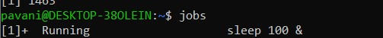
Report : The jobs command displayed the background job that was running. It showed the job number and its current status
46.bg:
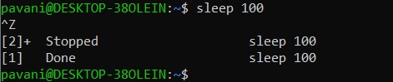
Report : After stopping the sleep process, I used the bg command to continue running it in the background
47.fg:
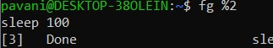
Report: I used the fg command to bring the background job back to the foreground so that it could continue running in the terminal.
48. &:
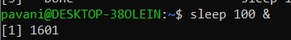
Report: By using &, the sleep command started running in the background, and I was able to continue using the terminal without waiting
TOPIC 8: File Permissions and links:
49. chmod:
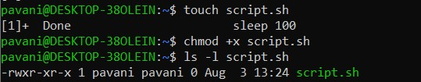
Report: I gave execute permission to the script.sh file using chmod +x. After checking with ls -l, I could see that the execute permission was added.
50. chmod 755:
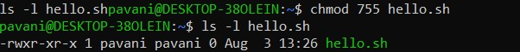
Report: I changed the permissions of hello.sh to 755. The file owner got full permissions, while the group and others received read and execute permissions.
51.ln:
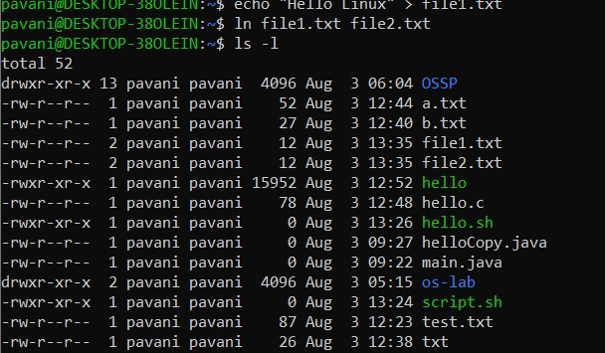
Report: I created a hard link named file2.txt for file1.txt. Both files referred to the same data on the disk.
52.ln -s:
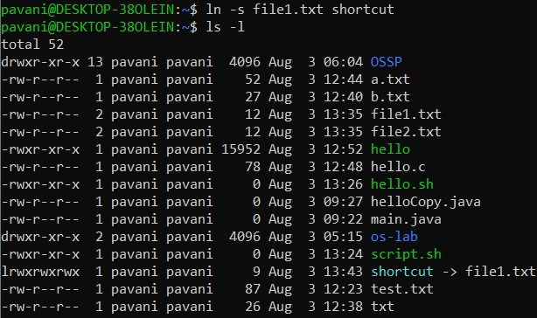
Report : I created a symbolic link named shortcut pointing to file1.txt. The link acted like a shortcut to the original file.
TOPIC 9:Disk and memory information
53. df -h:
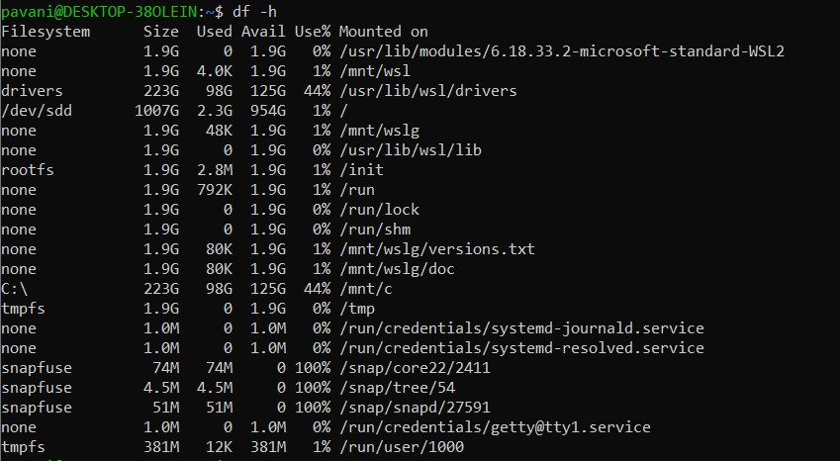
Report: The df -h command displayed the available and used disk space of the system in a human-readable format.
54. du -sh:
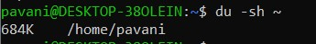
ReportI: checked the size of my home directory using du -sh ~. The command displayed the total space used by the directory.

55. free -h:
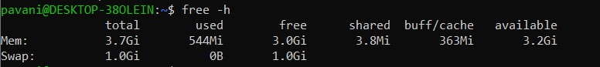
Report: The free -h command displayed the total, used, and available system memory along with the swap memory information

